File Handling :

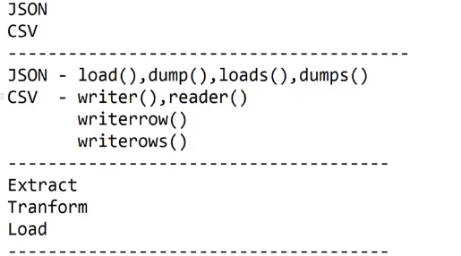

List slicing :

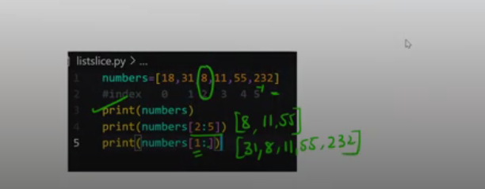

How to invoke rest API in python?

Requests module?

Rest API

How to test rest API ?

Rest API methods

GET

POST

PUT

DELETE

<https://www.flipcart.com>

how to consume rest API in frontend

and

Python – using Postman Tool

Task 1 :

Invoke/consume below rest API

And write user data into new user.json and user.csv file

Rest API info:

Rest API URL: https://jsonplaceholder.tvpicode.com/users

method Type : GET

Required Fields: None

Access Type: Public